ADVENTURE WORKS · TECHNICAL SUPPORT

E-Bike Won't Power On or Loses Range
E-Bike Document TS-019 Rev. A
Applies to | PowerRide e-Bike, City Cruiser-E
Difficulty | Beginner – Intermediate
Time required | 15 – 40 minutes
Tools needed | Manufacturer charger, Clean dry cloth, Soft brush for contacts

Symptoms
- The display or system won't turn on.
- The motor cuts out intermittently while riding.
- Range per charge has dropped noticeably.
- A battery error code appears on the display.
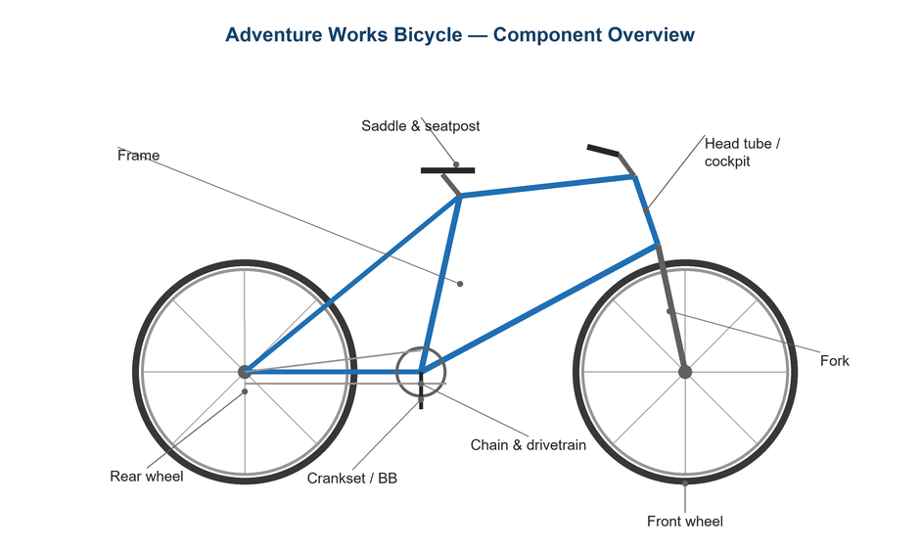
Figure 1. The battery, controller, and motor form the e-bike's power system.

Likely Causes
- A flat or deeply discharged battery.
- The battery isn't fully seated or locked into its mount.
- Dirty or corroded battery/controller contacts.
- Cold temperatures temporarily reducing capacity.
- Battery aging or a charger fault.
Safety first
- Use only the manufacturer's charger; the wrong charger is a fire risk.
- Never charge a visibly damaged, swollen, or wet battery — isolate it and contact support.
- Charge on a hard, non-flammable surface and don't leave charging unattended overnight.

Customer Fix — Step by Step
Suitable for home repair with basic tools. Work through the steps in order.
- Confirm the battery is charged: connect the official charger and watch for the charging indicator.
- Remove and reseat the battery, making sure it clicks fully into its lock.
- Inspect the battery and frame contacts; gently clean any dirt or moisture with a dry cloth/soft brush.
- Power-cycle the system: turn it fully off, wait 10 seconds, and turn it back on.
- Note any error code shown and check it against the owner's manual.
- If cold, let the battery warm to room temperature before judging range or charge.

Technician Reference
Additional checks and adjustments for service technicians and advanced users.
- Check the charger output and the charge port for damage or bent pins.
- Inspect the wiring harness connectors from battery to controller to motor for corrosion or looseness.
- Read diagnostic/error codes via the display or the maker's tool and follow the indicated procedure.
- Assess battery health/state-of-charge cycles if the tool reports it; aging cells reduce range.
- Verify firmware is current and assist levels/settings are correct for expected range.

Torque & Specifications
Item | Guidance
Charger | Manufacturer's unit only
Storage charge | ~40 – 60% for long storage
Charge temperature | 10 – 30 °C ideal
Contacts | Keep clean & dry
Error codes | Cross-check owner's manual

Figure 2. Follow the maker's battery and charging guidance precisely for safety.
Pro tips
- Store the battery around 40–60% charge in a cool, dry place to slow aging.
- Cold weather temporarily cuts range — capacity returns as the battery warms.

When to Visit a Service Center
- The battery is swollen, damaged, leaking, or very hot.
- An error code points to the motor or controller.
- Range has fallen far below spec on a healthy charge.
- The charger or charge port is damaged.
This guide is provided for reference. Torque values are typical starting points — always follow the specific component manufacturer's instructions. © Adventure Works.

